Kurnosenko Vitaly
Business Analyst | Corporate Finance | Banking Operations | Financial Reporting & Compliance | International Processes
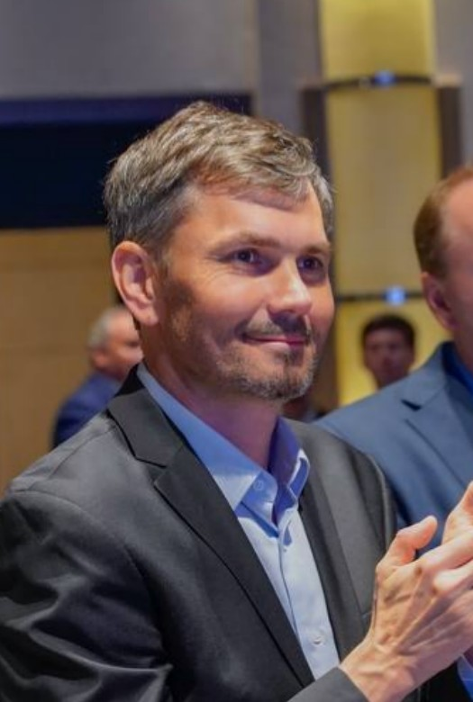
Location: Shanghai, China (ready to relocation Cypus, Serbia, Georgia, …)
Citizenship: Russia
Phone: +86 15601694273
Email: vitaliy@sinoptics.ai
WeChat: porohnya
telegram: vitaly_kur
Languages: Russian — native; English — fluent working proficiency; Chinese (Mandarin) — HSK 4

Professional Summary
Senior practitioner and financial leader with 15+ years of experience in corporate finance, treasury, management and financial reporting, internal controls, and international operations support. Strong expertise in plan-fact analysis, budgeting, cash flow forecasting, payment planning, banking processes, financial control, and compliance (including procedures based on legal documents, regulations, and IFRS/CAS).
Deep understanding of financial and operational processes in an international environment enables effective performance as a Business Analyst in the banking/fintech sector: eliciting business requirements, analyzing and optimizing financial processes, mapping workflows, supporting ERP/QAD system implementations, preparing analytical materials for stakeholders, and ensuring compliance with regulatory and internal requirements.
I combine financial expertise, systems thinking, data analytics (Excel/SQL/Python), and cross-functional coordination. Experience interacting with boards of directors, auditors, banks, counterparties, and HQ in a demanding international environment. Ready to contribute to product development, processes, and compliance at company.

Key Competencies (Business Analyst + Finance)
Business Analysis & Processes | Eliciting and documenting requirements, mapping financial and operational processes, optimizing workflows, supporting ERP/QAD implementations, gap analysis between business needs and systems
Financial Reporting & Planning | Budgeting, limits, plan-fact analysis, management reporting, scenario-based cash flow forecasts, monthly payment planning
Treasury & Banking Operations | Account administration, internet banking, payment execution, document control, bank interactions, support for loan attraction/repayment
Internal Control & Compliance | Financial control of payments and contracts, procurement/contractual regulations, pricing procedures, compliance with legal documents, internal procedures, and HQ requirements
IFRS / CAS & Audit | Participation in consolidated and non-consolidated reporting, mapping, interaction with external auditors, preparation of disclosures
Analytics & Data | Advanced Excel (pivot tables, formulas, VBA), SQL (MS SQL), Python for financial data processing, structured analysis of large datasets, reporting automation
International Operations & Stakeholders | Coordination with Russian/Chinese founders, board of directors, banks, clients, counterparties; support for capitalization, feasibility studies, and decision-making materials

Work Experience
Deputy Head of Economics and Finance Department — CRAIC (Shanghai, China)
December 2017 — Present
- Served as key business analyst for the finance function: analyzed business processes, elicited requirements for reporting and systems, configured financial reports in QAD to improve transparency and support management decisions.
- Developed and implemented budgeting, limiting, and plan-fact analysis procedures, ensuring alignment between operational needs and financial capabilities.
- Built cash flow scenarios and payment plans, identified liquidity risks, and proposed optimizations— directly relevant to BA tasks in banking for product and process management.
- Participated in quarterly/annual IFRS/CAS reporting, interacted with auditors, mapped data and process requirements.
- Ensured financial control and compliance of payment documents, contracts, and operations in accordance with legal documents and internal regulations.
- Coordinated with international stakeholders (board of directors, shareholders, banks), prepared analytical materials and roadmaps.
CFO — Shanghai Nine-Two-Nine Aircraft Design Limited Company (Shanghai, China)
November 2021 — 2025
- Launched the finance function from scratch for an international company: defined and implemented business processes, procurement policies, contract approvals, pricing, budgeting, and financial control.
- Performed the full cycle of business analysis of financial operations: from requirements gathering to configuring reporting and procedures, ensuring scalability and compliance.
- Developed cash flow scenarios, payment plans, and controls, identifying bottlenecks and proposing process improvements— experience directly applicable to analyzing banking products and client journeys.
- Organized interaction with auditors, including auditor selection, contractual work, and preparation of materials for the board of directors (feasibility studies, capitalization, charter capital).
- Supported banking operations and relations with banks and counterparties, ensuring the accuracy and timeliness of financial processes.
Executive Director — Engineering Solutions (China / Russia)
2013 — 2017
- Led procurement, sales, and foreign trade operations: analyzed market requirements, negotiated contracts, coordinated pricing and profitability in an international trading environment.
- Participated in financial planning and operational control, identifying business needs and translating them into financial and process solutions.
Executive Director — New Technologies (Moscow, Russia)
2008 — 2013
- Launched and managed operations with P&L responsibility: analyzed supply chains, pricing, profitability, and client requirements in an international environment (Southeast Asia).
- Implemented management accounting and financial control, optimized procurement and production processes.
Earlier Roles — 2003 — 2008
- Practical experience in management accounting, financial control, implementation of information systems (financial, production, management).
- Work with foreign trade, logistics, customs payments, Incoterms, cost calculation, and international contracts — understanding of end-to-end processes and compliance.

Education
• MBA, RANEPA, 2005-2007
• PhD in Physics and Mathematics, Southern Federal University, 2000-2003
• Physics Diploma, Southern Federal University, 1994-1999
• College of Radio-Electronic Instrumentation, 1991-1995

Certifications
• CAP — Certified Accountant Practitioner
• CPA Russia Professional Development Courses: financial accounting and IFRS reporting, management accounting, taxation of the Russian Federation, legislation of the Russian Federation
• Chief Accountant Courses

Fit for Business Analyst Role at company
• Deep experience in financial and operational analysis in a regulated environment, understanding of banking/treasury processes, reporting, compliance, and stakeholder interaction.
• Strong skills in requirements elicitation, process documentation, gap analysis, and system implementation support (QAD/ERP) — key for BA in fintech/banking.
• Expertise in data analytics (Excel, SQL, Python) for preparing insights, reporting, and automation.
• Proven experience in cross-functional coordination and communication with management, auditors, banks, and international partners.
• Ready to adapt to the specifics of company products (payments, lending, treasury services) and contribute to improving customer experience, internal processes, and regulatory compliance.

